**535/3 PHYSICS**

1. In this experiment you will determine the acceleration due to gravity using a simple
2. 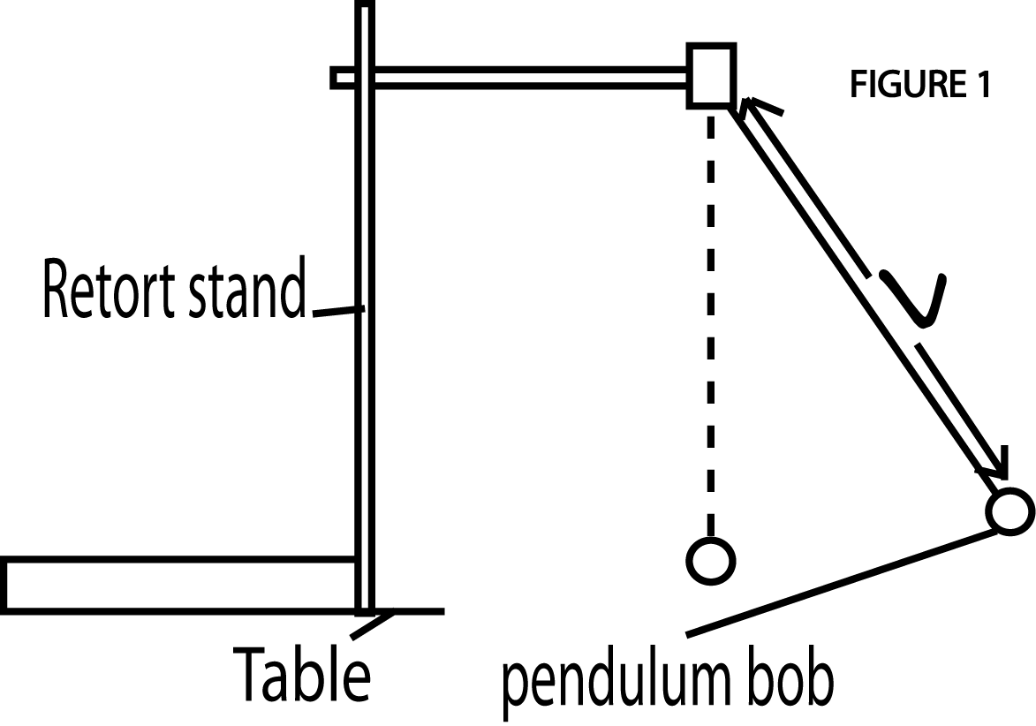pendulum.
3. Suspend the pendulum bob from a retort stand as shown in figure1.
4. Starting with a length $ι$ = 0.30m, displace the bob through a small angle and release it.
5. Determine the time for 20 oscillations
6. Determine the periodic time T for the one oscillation.
7. Repeat procedures (b) to (d) for the values of $ι$ = 0.40, 0.50, 0.60, 0.70 and 0.80m.
8. Record your results in a suitable table including values of T2.
9. Plot a graph of T2 against $ι$
10. Find the slope s of the graph.
11. Calculate the acceleration due to gravity (g) from the expression

S = $\frac{4π^{2}}{g}$

|  |  |  |  |
| --- | --- | --- | --- |
| **(cm)** | **t(s)** | **T(s)** | **T2(S2)** |
| 0.30 | 22.0 | 1.10 | 1.21 |
| 0.40 | 27.0 | 1.35 | 1.82 |
| 0.50 | 29.0 | 1.45 | 2.10 |
| 0.60 | 32.0 | 1.60 | 2.56 |
| 0.70 | 34.0 | 1.70 | 2.89 |
| 0.80 | 35.0 | 1.78 | 3.16 |

s= $\frac{3.26-1.18}{0.83-0.21}$

s=3.36

g= $\frac{{4π}^{2}}{s}$ = $\frac{{4π}^{2}}{3.36}$

g=11.7ms-2

1. In this experiment, you will determine the refractive index **n** of the material of the glass block provided

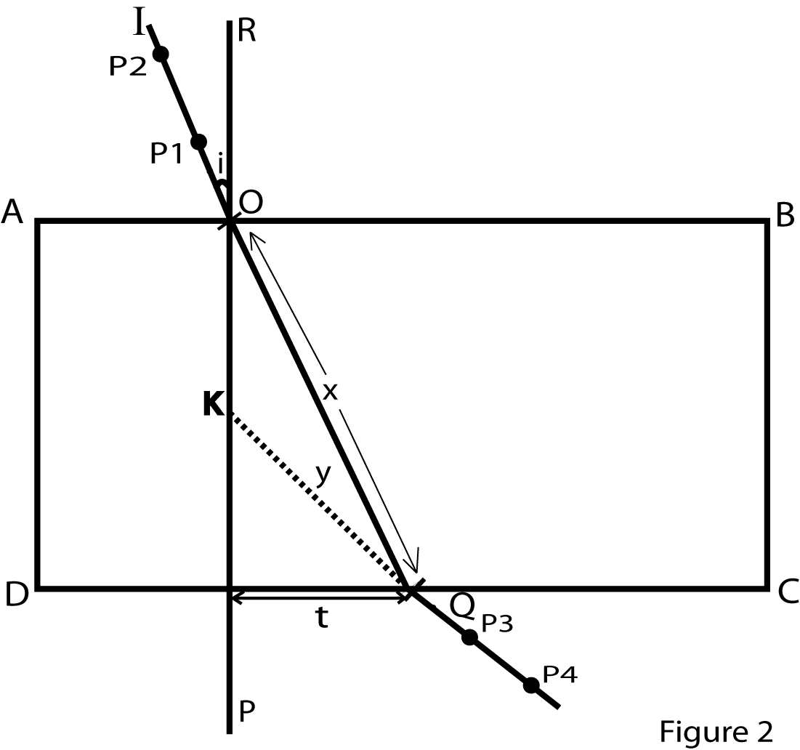

1. Fix a white sheet of paper on a soft board using drawing pins.
2. Place a glass block on a white sheet of paper with its broad face upwards and trace its outline ABCD.
3. Remove the glass block
4. Draw a normal PR at 0, 2m from AD
5. Draw a line IO such that angle i= 100
6. Fix pins P1, and P2 vertically along I O
7. Replace the glass block on its outline
8. Looking through side DC fix pins P3 and P4 such that they appear to be in a straight line with the images of P1 and P2 as shown in figure 2
9. Remove the glass block and the pins and draw a straight line, through P3 and P4 to meet DC at Q.
10. Join Q to O and measure distance Q call it x
11. Produce the line through pin marks P3 and P4 to meet the normal at K
12. Measure distances t and y
13. Repeat procedures (e) to (*l*) for values of i = ${20}^{0}$, ${30}^{0}$, ${40}^{0}$, ${50}^{0}$ and ${60}^{0}$
14. Record your results in a suitable table including values of $\frac{t}{y}$ and $\frac{t}{x}$
15. Plot a graph of $\frac{t}{y}$ against $\frac{t}{x}$
16. Find the slope **n** of the graph

|  |  |  |  |  |  |
| --- | --- | --- | --- | --- | --- |
| **I(0)** | **T(cm)** | **Y(cm)** | $x$**(cm)** | $$t/y$$ | $$t/e$$ |
| 10 | 0.9 | 5.0 | 6.7 | 0.180 | 0.134 |
| 20 | 1.5 | 4.5 | 6.8 | 0.333 | 0.221 |
| 30 | 2.3 | 4.3 | 7.0 | 0.545 | 0.329 |
| 40 | 3.1 | 4.6 | 7.4 | 0.674 | 0.419 |
| 50 | 4.2 | 5.3 | 7.8 | 0.792 | 0.538 |
| 60 | 5.2 | 5.8 | 8.4 | 0.897 | 0.619 |

n= $\frac{1.040-0.100}{0.700-0.70}$

n = $\frac{0.94}{0.63}$

n = 1.49

***HAND IN YOUR TRACING PAPER TOGETHER WITH OTHER ANSWER SHEETS***

1. In this experiment you will determine the resistivity $ρ$ of the bare wire provided

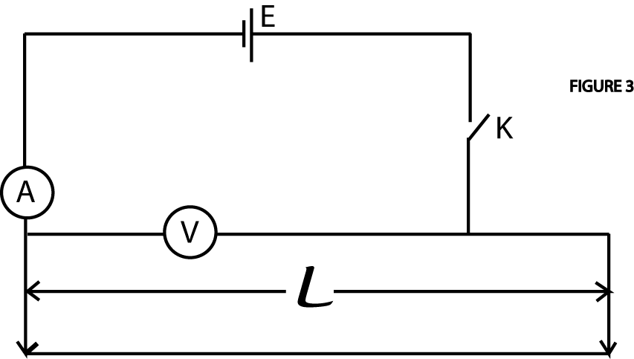

1. Connect the cell, ammeter, voltmeter, switch and the bare wire as shown in figure 3
2. Adjust the length $ι$ of the bare wire equal to 10.0cm.
3. Close the switch K
4. Read and record the voltmeter reading V and the ammeter reading A
5. Open the switch K
6. Repeat procedures (b) to (e) for values of l= 20,30, 40, 50, 60 and 70 cm
7. Record your results in a suitable table including values of $V/I$
8. Plot a graph of $V/{I }$ against $ι$.
9. Find the slope s of the graph.
10. Calculate the resistivity $ρ$ of the wire from the expression $ρ$ = 5.4106 x 10-5 s

|  |  |  |  |
| --- | --- | --- | --- |
|  | **V(v)** | **I (A)** | **(Ω)** |
| 10 | 0.55 | 0.56 | 0.98 |
| 20 | 0.75 | 0.42 | 1.79 |
| 30 | 0.85 | 0.36 | 2.36 |
| 40 | 0.95 | 0.30 | 3.17 |
| 50 | 1.05 | 0.26 | 4.04 |
| 60 | 1.10 | 0.24 | 4.58 |
| 70 | 1.15 | 0.22 | 5.23 |

s= $\frac{5.5-0.51}{74-30}$

s=0.0703

$$\int{=5.4106x{10}^{-5} s}$$

$$\int{5.4106 x{10}^{-5}} x 0.0703$$

$\int{=3.803 x{10}^{-6}}$ Ωm

**END**